**Guidance Utility for Impaired Daily Experiences (GUIDE)**



*Project Proposal*

GUIDE

Alyan Tharani

Jack Couture

Jack Letsinger

Noah Kilpatrick

Ryan Wu

Diana Canchola

Department of Computer Science

Texas A&M University

September 19, 2024

Table of Contents

1 Executive summary 2

2 Introduction 4

2.1 Needs statement 4

2.2 Goal and objectives 4

2.3 Design constraints and feasibility 4

3 Literature and technical survey 5

4 Proposed work 7

4.1 Evaluation of alternative solutions 7

4.2 Design specifications 8

4.3 Approach for design validation 12

5 Engineering standards 13

5.1 Project management 13

5.2 Schedule of tasks, Pert and Gantt charts 14

5.3 Economic analysis 15

5.4 Societal, safety and environmental analysis (1/2 page; 2 points) 15

5.5 Itemized budget 16

6 References 17

7 Appendices 18

7.1 Product datasheets 18

7.2 Bios and CVs 24

# Executive summary

Ever since the creation of the walking stick in 1947, there has been little innovation for the visually impaired to better navigate their surroundings. Over 200 million people suffer from visual impairment, with over 50 million being classified as fully blind. The environment that these people navigate through daily is constantly changing, and the ability for the walking stick to detect the user’s surroundings is limited.

GUIDE, short for Guided Utility for Impaired Daily Experiences, aims to improve the detection of objects in the environment by utilizing LiDAR sensors and depth perception technology to calculate the distance of an object from the user, and to provide a vibration on the handle of the walking stick. This vibration varies in strength depending on the distance of the object, with closer objects providing a stronger vibration.

The information collected by the sensor and camera is then sent to a Raspberry Pi Pico 2 that utilizes software designed to determine whether the object detected is tangible. The Pi serves as the product’s microcontroller, transferring and computing data from the sensors to the rumblers. This data is then used to send out a vibration of varying strength depending on object distance. A small battery is included to power the hardware, and is replaceable with a 3-4 hour battery life.

The LiDAR sensor and depth perception camera work together to produce clearer data for the software engine to process, and ultimately provides more accurate vibration strength. The Raspberry Pi is capable of very fast response times, with vibrations expected to occur within less than 0.5 seconds of detection. The vibration sensors are located within the grip of the handle, which will also indicate the placement of the sensors for the user, so that the camera will face the correct direction at all times.

GUIDE is designed to be affordable and accessible for the general population. Economic backgrounds of users will vary greatly, and it is important that this product can be afforded by people who are in need. The parts chosen for this product are of good quality and are affordable, with the combined cost of parts and manufacturing totaling $230. GUIDE is made to be long lasting, which allows the product to be affordable in the long run for most users while still maintaining quality. Accessibility is also taken into account, as the stick is collapsable and can easily be carried around in public spaces without causing disruption. Weight was also a major factor in the choice of parts used, as a walking stick that is too heavy may limit the user’s ability to fully make use of the range of detectability. The goal set for the design of the stick is to be less than two pounds.

To ensure that the software and hardware can effectively communicate, vigorous testing will be conducted. The product will be tested on the campus of Texas A&M University, and will include many trials in varying conditions. The conditions for these tests will vary, with outside temperatures ranging from 60 to 90 degrees, in addition to various weather conditions alongside time of day. This will ensure that the product will work at all times of the day, at any location, and in any weather condition.

# Introduction

## Needs statement

The visually impaired population makes up around 285 million people all over the world, 50 million of which are completely blind according to the World Health Organization. Although there have been many innovations to accessibility and our infrastructure, it remains difficult to navigate certain environments such as university campuses. The current limitations for the visually impaired include the inability to detect obstacles in front of them and the distances of those obstacles. Knowing these two pieces of information can better aid the visually impaired in navigating college campuses, making higher education more accessible. The current solution involves static walking sticks that can signal the visually impaired if an obstacle is in front of them when the stick touches the obstacle. This design became collapsible but has not seen any other major changes since 1947. With the technology available today, the walking stick is in desperate need of an overhaul to allow users to have a better understanding of what the terrain is like and what is ahead of them rather than only knowing what the stick has touched.

## Goal and objectives

GUIDE is geared towards visually impaired individuals, serving as a means to detect obstacles and to provide feedback to the user to alert them of their surroundings. Through depth detection connected to a vibrating handle, GUIDE will inform the user of their surroundings and any obstacles in their way as well as the relative distance from the obstacle. It will allow for changing sensitivity to allow the user to have more control over their experience. GUIDE will provide real-time feedback with delays of less than 0.5 seconds to its users. It will allow for different metrics to be modified so users can tune the performance to their needs and wants. GUIDE will use a depth camera and LiDAR working in combination to detect obstacles 2 meters away and provide real-time feedback, allowing visually impaired users to navigate safely and independently in various environments. GUIDE will use affordable, high-quality parts and materials, and will not exceed the budget of $300. The design will not be intended to be replaced, but rather last as long as the warranties of the parts allow. GUIDE will be powered by commercially available batteries that can be replaced when out of charge with a battery life of 3-4 hours. In the event of a future iteration, it should include charging capabilities. GUIDE will be able to operate at any time of day, as well as both indoors and outdoors. While not completely submersible, it will be able to withstand small amounts of water in the event of rain or spills.

## Design constraints and feasibility

A major constraint as mentioned previously is the power supply. GUIDE will have to have the batteries manually replaced following a 3-4 hour use window. This is due to factors such as cost as well as structure. The current power supply is very cheap and easy to work with whereas a charging setup with a port can become very expensive very fast in order to fully implement. The $300 budget would instead be better spent on better LiDAR and other technologies that can improve the functionality of the device. Furthermore, having a charging set up in the walking stick or its handle leaves little room for other critical devices such as the vibrator motors and their wiring. So, to implement this, the walking stick would need to have an even larger handle and larger diameter of the stick, completely changing the structure of GUIDE. Thus, the objectives and goals we have set have focused on feasibility within the budget as well as ensuring the complexity does not exceed the amount of time we have to work with. Overall, the only other major constraint is the cost of technologies such as LiDAR. As mentioned, that is where we have decided to place most of our budget. This is because LiDARs are usually fairly expensive and with our budget, we cannot afford a top-of-the-line LiDAR. However, for this project to be feasible, we do need a LiDAR that can work efficiently and consistently in our system which is why it is a large chunk of our budget. With a larger budget, we could acquire a better LiDAR and maybe a better depth camera, but the project is still very much feasible under budget constraints.

# Literature and technical survey

Lazarillo (Smartphone-based Navigation Apps)

For the first review, we chose to look at Lazarillo[2], a GPS App marketing itself as free and accessible for the blind and visually impaired. While a promising solution that has no additional equipment to carry, the main issue was a lack of location updates.

Pros:

* Widely accessible, most people already own smartphones
* Can leverage existing GPS and mapping technology
* Easy to update and improve software

Cons

* Requires users to hold or wear their phone constantly
* May not provide precise enough guidance for close-range tasks
* Battery life concerns for all day use.

Obstacle Detection in Infrared Navigation for Blind People and Mobile Robots (Infrared Sensor for Object Detection)

A research paper from Robotic Systems and Automatic Control: Mathematical Models, Technologies, Applications and Challenges[4] proposes an infrared-based navigation system for blind individuals and mobile robots, capable of detecting obstacles like corners in indoor environments. The system utilizes temperature differences near wall corners, providing a low-energy solution that doesn’t require additional equipment beyond a small infrared camera.

Pros:

* Low power consumption
* Can work in low light conditions
* Lower cost compared to conventional computer vision systems

Cons

* Limited range and accuracy
* Cannot provide information about object type or colors
* may struggle with certain materials that don't reflect infrared light well

NaviBelt (Bag/Belt Attachment with Cane)

The NaviBelt[5] is a wearable device with 16 vibration units, which “guide” you to either to true North or your destination. NaviBelt is barrier free with no handling, and even provides increased spatial awareness benefits to those without vision impairments. While it does improve orientation, it appears to be optimal when supplemented by traditional devices such as a white cane.

Pros:

* Hands-free design
* Benefits of navigation to non-impaired users
* Smartphone connectivity

Cons

* Forced to “wear” the product, regardless of personal dress and fitness habits
* Potential weight or uncomfortableness when running or walking at accelerated speeds
* Battery life

SPOT walking robot with camera (Camera Object Recognition)

SPOT[6], similar to the Boston Dynamics robot, is an all 4-legged autonomous robot that can perform security patrols, take measurements, or even assist visually impaired people with its camera. Similar to a guide dog, SPOT could be programmed to “see” for its user by walking ahead and warning / describing the environment.

Pros:

* Hands free, separate robot
* Can ‘act’ as a seeing eye dog, be of assistance in ways beyond visual guidance

Cons

* Extremely low battery life
* Large and potentially disruptive in delicate environments
* Extremely expensive

Wewalk (AI integrated smart cane)

Wewalk[7], a smart cane offering AI features such as GPT integration, is a cane that has been in development since 2011. It claims to have enhanced obstacle detection, provide an intelligent voice assistant, accessible navigation, as well as the ability to discover public transit live.

Pros:

* Cutting edge AI technology
* Access to public transit
* Voice assistant support and phone connectivity

Cons

* On backorder for 5+ years
* Over promised on features, no product shipped to date
* Constant need for internet access

Our research has concluded that GUIDE poses some unique advantages, such as not needing a phone like Lazarillo. Unlike typical infrared-based systems, GUIDE uses both a LiDAR and a depth camera, potentially offering more detailed and accurate obstacle detection. Compared to NaviBelt, GUIDE does not require the user to wear any additional equipment, making it less intrusive. While not technically advanced as an AI-powered robot solution like SPOT, GUIDE is significantly more affordable and portable. Finally, in contrast to products such as WeWalk, GUIDE aims to be a more immediately realizable solution using readily available components.

While GUIDE may not offer some of the advanced features of AI-powered or smartphone-integrated solutions, it targets a niche that prioritizes practical, reliable, and affordable assistance for daily navigation tasks. Its focus on enhancing rather than replacing the traditional white cane sets it apart as a solution that respects existing habits while providing meaningful technological improvements.

# Proposed work

## Evaluation of alternative solutions

Alternative Solution 1: Phone Application with Audio

This solution involved object detection and alert via a smartphone application which would audibly output the obstacles ahead of the user. The application would allow the user to edit the settings of the device as well as connect headphones to hear the alerts or play them outloud.

Pros

* The application gives the user a central, customizable interface with the device.

Cons

* Audio cues could audibly impair the users as well as surrounding people.
* Audio cues could be hard to understand or hear in loud environments, particularly college campuses.

Alternative Solution 2: SLAM Algorithm to Add Obstacles to Database

This solution involved adding an additional feature, a database containing obstacles. The cane would have GPS capabilities and keep track of obstacles encountered by adding them to a database. This database would help the algorithm detect accurately if there were any obstacles in front of the user.

Pros

* The database allows the software to rely on the sensors and previous information.

Cons

* The database and collection of data are a stretch goal, they prove time consuming.

Alternative Solution 3: Infrared Sensor for Object Detection

The use of an infrared sensor for obstacle detection was floated by the team when brainstorming what hardware and electronics would work best given our elected environment.

Pros

* The IR sensor adds visibility to the software and can help paint a better picture of the environment.

Cons

* The device must cover 2m of distance and function in all temperatures, the IR sensor is not best suited for this.

Alternative Solution 4: Bag/Belt Attachment with Cane

This solution included adding a wearable belt/bag with the battery and wires to store the device hardware.

Pros

* The attachment allows a means to store equipment for the cane.

Cons

* The added accessory can be cumbersome for the user to carry.

Alternative Solution 5: Camera Object Recognition

This solution adds functionality to the object detection by deducing what obstacle is in front of them in addition to the distance.

Pros

* This solution gives the user a better idea of their environment and what is physically in front of them.

Cons

* Due to time constraints and budget we elected to keep the detection simple.

## Design specifications

GUIDE’s solution involves both hardware and software components working together to reach the goals and objectives outlined in this report. The design includes various electronic sensors such as a LiDAR and depth camera. The combination of these two sensors are used to determine something in front of the user is an obstacle and the distance between the obstacle and the user. When the electronic sensors have collected the information from the environment such as distances it will send this data to our software hosted in the microcontroller. The electronic sensors will be mounted using a ring that allows for angle adjustments to ensure the best angle for detection is used.

The software will make a determination the object being detected is an obstacle and the distance between the user and the obstacle. Depending on the distance, GUIDE will trigger a response from the vibration motors.

The vibration motors will begin vibrating when the obstacle is 2m away and increase intensity as the user moves closer to the obstacle. When the user is 2m away the vibration motors will start vibrating, and the intensity will increase at 1m, 0.5m, and 0m. The vibration motors will be within the grip of the cane handle. The cane will have a power button at the top part of the handle. This button will help the user conserve energy by powering the device and all electronic components off when not in use.

The RaspberryPi Pico 2 will be used as the microcontroller, storing the software for the cane and connecting the electronic components. Commercially available batteries will be used to power the entire cane.

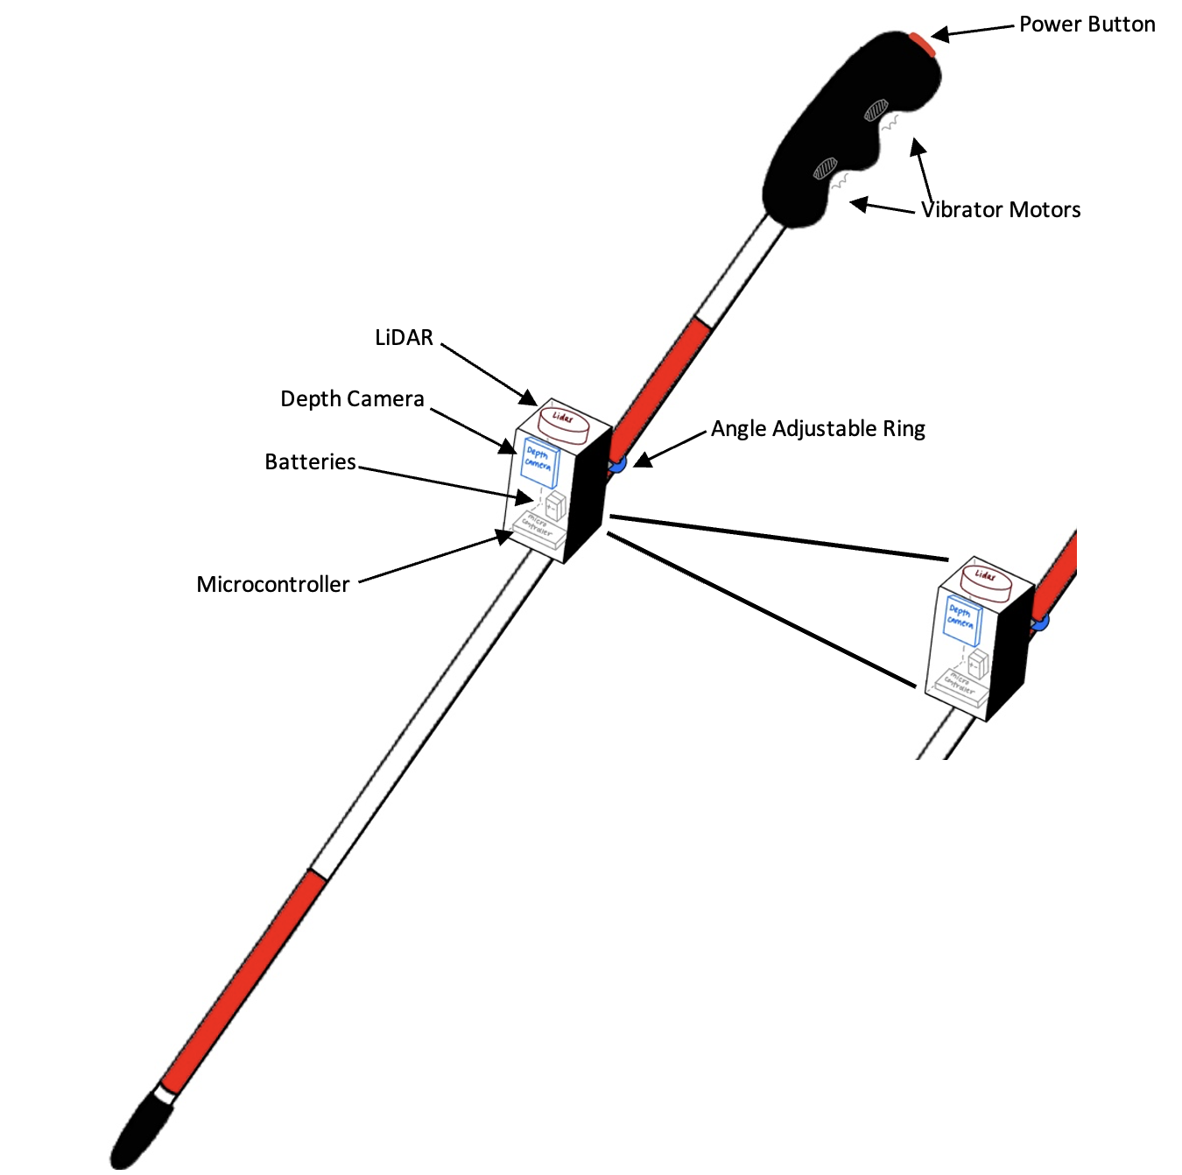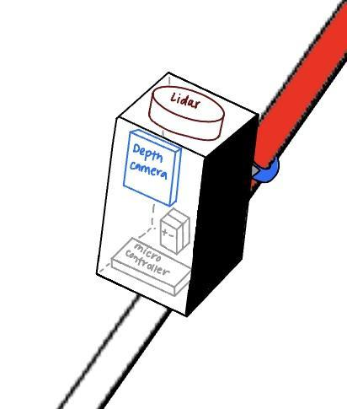

Figure 1: Rough sketch of the GUIDE cane including all hardware components. The electronic sensors,

LiDAR and depth camera will be placed in an attachment whose angle is adjustable. The power button and

vibration motors will be housed in the handle. The figure shows the microcontroller holding the software and

connecting the electronic components as well as the battery powering the entire system. Note the figure

points to a larger scale image of the electronic components.

At a high level, GUIDE has 5 main components; two sources of input, the software data engine, and two outputs for the users and stakeholders. The obstacle detection is done using both the LiDAR and depth camera. Both components will send their data to our data engine written in c++ where it will determine whether the object detected is an obstacle and the distance between the user and obstacle. Once this is determined it will output a video of the environment for testing and stakeholder purposes. Additionally, it will keep track of the distance between the user and the obstacle to begin vibrating the handle at 2m, 1m, 0.5m, and 0m distances.

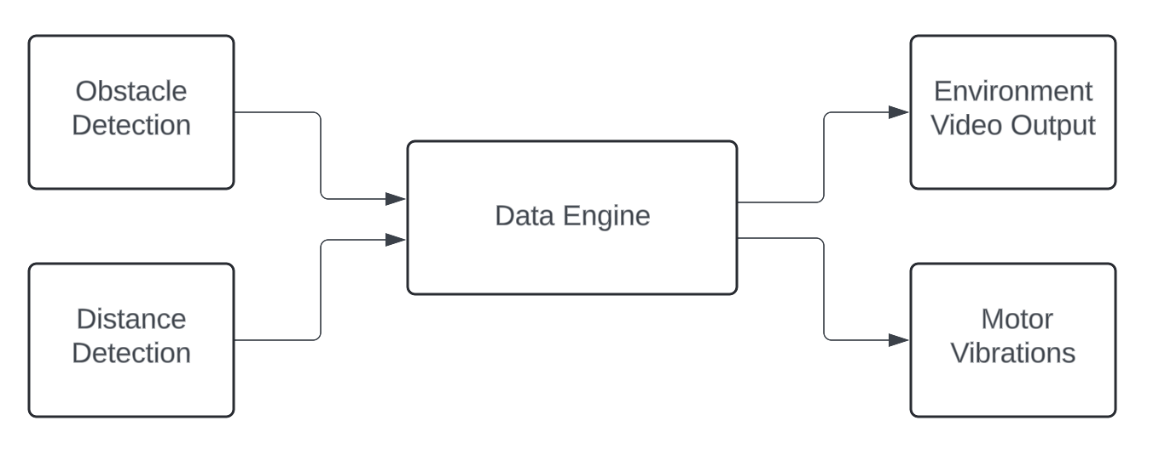

Figure 2: High level block diagram of the major system components of GUIDE. The system takes two inputs, data from the LiDAR and depth camera. These two inputs are sent to the software data engine where they are interpreted and two outputs are generated. The software generates a video for stakeholders understanding of the environment as well as testing and vibrations in the handle for the users.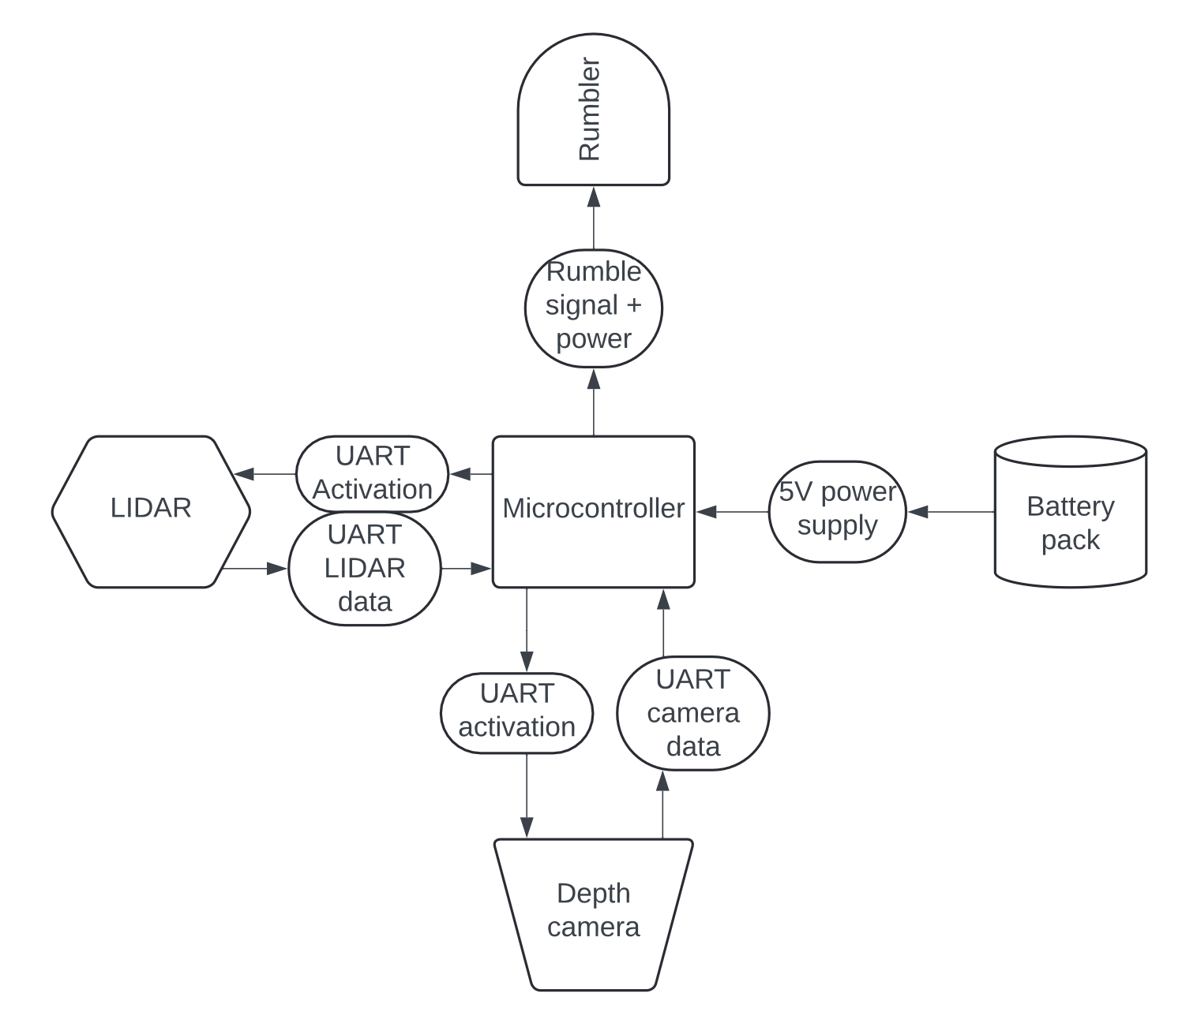

Figure 3: More in depth diagram of the hardware components and protocols   
 needed to establish communication. The microcontroller sits in the middle   
 of the system with 4 major components connected, the LiDAR,   
 depth camera, battery, and rumblers/vibration motors.

Figure 3 describes the hardware components to be used in our design as well as how each will interact with one another. At the center of the hardware design is the microcontroller. We have selected the Raspberry Pi Pico 2 as it is extremely power efficient, it is light-weight, it has UART capabilities for our electronic sensors, it can support both python and c++ development and it utilizes the Raspberry Pi SDK which all our members are familiar with.

Communicating via UART are two of our electronic sensors, the LiDAR and depth camera. Both of these sensors provide vision in a different way, combining the two will allow us to make the best determination of an obstacle and its distance. The LiDAR scans the surroundings in a cone while the depth camera measures objects in a frontal cone pattern. The LiDAR operates through the sensor emitting laser pulses into the environment and measuring how long it takes for the pulses to return. Through this elapsed time, the LiDAR can calculate the distance between the sensor and the object that reflected the pulses. The depth camera has two main functions, Time-Of-FLight (TOF) and RGBD data. The TOF capability allows the sensor to emit an infrared light pulse and measure the time it takes to reflect the pulse back to the sensor. This camera gives us both image capabilities and IR sensing. As the time is directly proportional to the distance calculated, the camera outputs a depth map describing the three dimensional environment. Additionally, the camera captures RGB images and the depth of the images, rendering a three dimensional image/video of the environment. The microcontroller will activate both sensors when the cane is turned on and through UART cables the LiDAR and camera will send the microcontroller data about the environment. The Pico microcontroller is UART compatible.

The rumblers located in the handle, vibrating at the detection of an obstacle will be connected to the microcontroller. The rumblers will receive power from the microcontroller as well as a command to begin vibrating and at what intensity.

The hardware components will be powered by commercially available batteries. The batteries will output 5V directly to the microcontroller. The microcontroller will then distribute power to each of the hardware components.

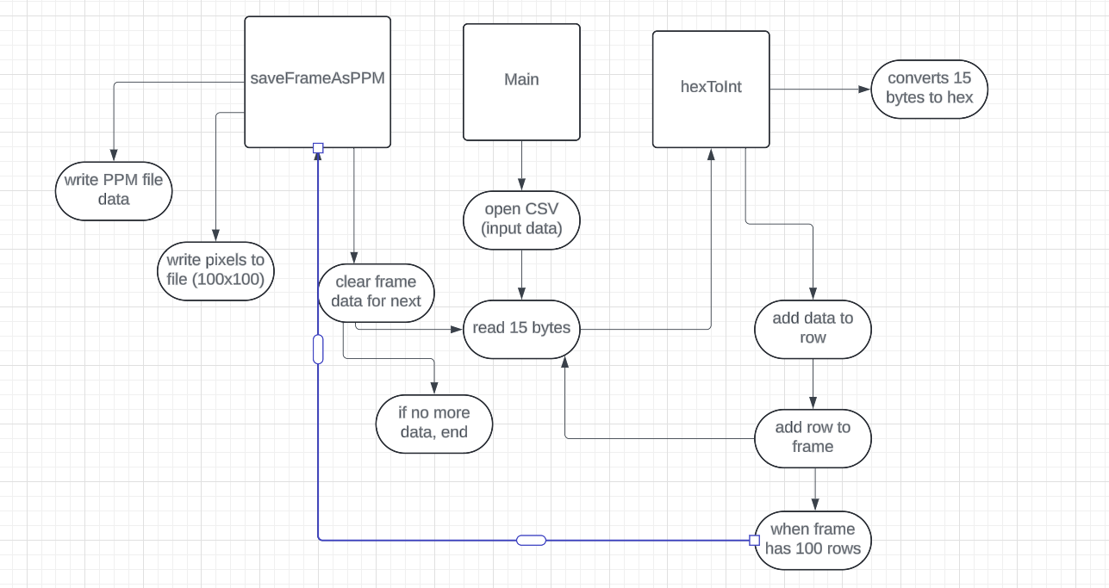

Figure 4: More in depth diagram of the software components of the data engine. The diagram describes how the images

from the depth camera will be interpreted by the main program. This interpretation of the data will result in a

comprehensive understanding of the users environment.

Figure 4 provides an in depth view of the programs running on our microcontroller. The main program receives a CSV file as an input from the depth camera and distances from the LiDAR. This program will utilize two functions, saveFrameAsPPM and hexToInt. Initially, the CSV data will be sent to the hexToInt function which will convert the bytes into hex values and add them to a row. Once the program has reached 100 rows the hex values will then be sent to the saveFrameAsPPM function. Within this function the pixels will be written to a file and a PPM file will be generated. The PPM file will allow us as developers and stakeholders to understand what the sensors are receiving from the environment.

Once the main function receives the images and the distance measurements from the LiDAR it will trigger a response if the determination of an obstacle is made and the distance is within 2m. As the microcontroller is connected to the rumblers, the main function will call for an action from the rumblers and adjust their intensities.

Table 1: A parts list of materials that are needed to build GUIDE. This list of materials contains the amount, cost associated with the unit to purchase, dimensions, weight and total we are expecting to pay for the part.

|  | Amount | Amount per Unit | Cost per Unit | Dimensions | Weight | Total Amount ($) |
| --- | --- | --- | --- | --- | --- | --- |
| Walking Stick | 1 | 1 | $17.99 | 53in x 0.5in - Rod  7in x 1in - Handle | 0.55lb | $17.99 |
| Power Button | 1 | 1 | $9.99 | 16mm | 0.35 ounces | $9.99 |
| Vibrating Motor | 2 | 8 | $7.59 | 10mm x 2.7mm | 0.63 ounces | $7.59 |
| LiDAR | 1 | 1 | $99.00 | 10mm x 2.7mm | 11.2 ounces | $99.99 |
| Depth Camera | 1 | 1 | $43.00 | 10mm x 2.7mm | 10.6 ounces | $43.00 |
| Lithium Ion Battery | 2 | 4 | $12.99 | 10mm x 2.7mm | 44g | $12.99 |
| Raspberry Pi Pico 2 | 2 | 2 | $12.50 | 21mm x 51mm | 4g | $12.50 |
| Battery Pack Holder | 3 | 3 | $5.33 | 7.83 x 5.51 x 1.38 inches | 2.39 ounces | $15.99 |
| Total (s) |  |  |  |  |  | $220.04 |

Table 1 above details all the components we will be utilizing to build GUIDE. These components were selected due to various reasons all aligning with our goals and objectives. We must maintain a weight of or less than 2lbs. The components must be small enough to allow the cane to be collapsable. All of the components above can be measured in millimeters or a few inches. This will allow us to create a compact design, adding little to the cane without compromising quality. The weight of all the added components puts the overall weight just under 1.5lbs. This relatively low weight will allow users with a wide range of physical abilities to comfortably use GUIDE.

## Approach for design validation

The main objectives of GUIDE as stated in the sections above are to provide increased mobility to the visually impaired through obstacle detection and user alerts. These objectives are vital to the success of GUIDE and in the independence of those with visual impairments. Given our environment is a college campus we will be conducting all testing at Texas A&M University. We have allotted 3-4 weeks of integration testing as well as design validation.

The first objective is testing for mobility. GUIDE must be less than 2 pounds. To test this we will weigh the final design to ensure it is lightweight and every user regardless of physical ability and age is able to use GUIDE. In addition to weighing the cane we will walk with GUIDE around the university campus to ensure it does not cause strain to the user's arm for 20 minutes. GUIDE must be collapsable to ensure it is portable and users can store the cane easily. To test this we will ensure the final design can be collapsed and held in one hand, as the original design. Lastly, to ensure mobility, the team will power GUIDE for 3-4 hours to ensure it is fully functional for the duration of the battery’s life. At each half hour we will assess how the accuracy of each component has changed when yielding results.

The second objective of GUIDE is to detect obstacles using a LiDAR and depth camera. To ensure each component is functioning properly we will check each separately. We will test the depth camera by ensuring the videos and images output reflect the real-time environment being seen by the user. To do this we will test the camera attached to a computer with graphical capabilities and walk through the campus. This will be done in sunny, cloudy, rainy weather, and temperatures ranging from 90 degrees to 60 degrees. The LiDAR will be tested similarly but we will output the distances from obstacles using a computer terminal. To ensure these values are accurate we will physically measure the distance using a tape measure. These tests will be completed on the college campus in sunny, cloudy, rainy weather, and temperatures ranging from 90 degrees to 60 degrees. Once each component is tested separately we will integrate the two and ensure functionality does not become compromised. As GUIDE must detect obstacles 2m away from the user we will walk through the campus and run five tests. The first test will ensure if there is no obstacle 2m away the cane will not alert the user. The second test will place various obstacles within 2m of GUIDE. We will test using common obstacles on a college campus such as, curbs, medians, sidewalk barriers, pedestrians, bikes, scooters, squirrels, and cars. The third test will use the same subjects as test 2 but the distance between the obstacles will decrease to 1m. The fourth and fifth tests will use the same subjects as test 2 but the distances will decrease to 0.5m and 0m. As stated earlier, these tests will be completed in sunny, cloudy, rainy weather, and temperatures ranging from 90 degrees to 60 degrees. During these five tests we will print the distance and view the images/videos through a computer with graphical capabilities.

The last objective of GUIDE is to alert users when an obstacle is 2m, 1m, 0.5m, and 0m away and have less than a 0.5 second delay. The user must be alerted within 0.5 seconds there is an obstacle in front of them. To ensure this is true, we will collect timestamps and telemetry from the software of when the obstacle was detected and at what time the rumblers on the handle started vibrating. If the delay is not within 0.5 seconds we will look into optimizing the software to ensure latency meets the requirement. In addition to testing delay time, to ensure the user is alerted according to our requirements and objectives we will test the intensity of the rumbler at different distances. There will be a total of 4 tests where we will first test if the rumblers are triggered once an obstacle is detected 2m away from the user. The next test will be completed similarly but we will measure 1m away from the obstacle and ensure the rumblers increase the intensity of the vibrations. Next, we will measure 0.5m between GUIDE and the obstacle and make sure the rumblers are triggered with an even higher intensity. Lastly, once the obstacle is 0m away we will test the rumblers and have them set as the maximum vibrations, per the users sensitivity levels.

When completing the integration and testing portion of the schedule we would have validated our design can detect obstacles 2m away, respond for distances 2m, 1m, 0.5, 0m within 0.5 seconds and can have full functionality for 3-4 hours without causing physical strain due to weight or collapsibility.

# Engineering standards

## Project management

Our entire team has experience with Raspberry Pi, hardware, full-stack development, and software-hardware integration. Further details on each individual's strengths and experience can be found in our CVs and Bio’s below.

Diana Canchola - Team Lead

As the team lead, Diana will oversee the overall project and its direction. She will ensure that we are on schedule and meeting all required deadlines, while also facilitating communication between team members. Additionally, she will make sure that our priorities are aligned, as the project spans only one semester. Diana is responsible for high-level decision-making and will assist both the hardware and software teams.

Jack Couture - Software Lead

As the software lead, Jack will focus on writing the control algorithms for GUIDE, interpreting distances, and processing the data from the distance cameras to generate outputs for the user. He will also manage the communication interface between the hardware and software, working closely with Jack Letsinger, the hardware lead. Additionally, Jack will test the software components to ensure both reliability and accuracy in the system.

Jack Letsinger - Hardware Lead

As the hardware lead, Jack is responsible for selecting and integrating the components used in the system, such as distance cameras, vibration motors, and microcontrollers, ensuring compatibility and functionality. He will oversee the hardware development and manage testing to meet performance specifications.

Alyan Tharani - Hardware Developer

As part of the hardware team, Alyan will be responsible for hardware integration and system design. Additionally, he will develop 3D-printed parts and provide them to the team for the tool’s construction. He will also work on assembling the hardware components, ensuring flexibility in the design of the camera mounts and other elements. Alyan will help with system testing and validate the system’s performance across different environments.

Noah Kilpatrick - Software Developer

As part of the software team, Noah will be responsible for developing the software, including coding control algorithms for the microcontrollers and integrating sensor data into actionable feedback. He will work closely with the hardware team to ensure that the software runs smoothly and meets performance objectives, such as low latency.

Ryan Wu - Hardware Developer

As part of the hardware team, Ryan will focus on assembly and ensuring compatibility with the software systems. He will also lead in developing technical documentation and work alongside the team to integrate all the hardware components. Ryan will help ensure the project adheres to engineering standards and contribute to system testing across different environments to ensure optimal performance.

## Schedule of tasks, Pert and Gantt charts

The schedules below describe the timeline of our project development using a Gantt chart and Pert chart. The schedule of GUIDE begins with developing a project proposal in both presentation form and a report. This proposal will be geared towards our stakeholders.

Following the proposal we will begin the development stage where the hardware team will order, test and prototype the electronic components. This stage will also include software development where we will store each version of the code in a git repository. A virtual machine has already been set up where the sensors will be connected 24/7. The software team will have access to the hardware for testing through their own machine. This stage will end with a software prototype Once each prototype is complete we will begin the integration and testing phase as well as design validation. This stage has 3-4 weeks allotted to ensure the final product meets our goals and objectives. Lastly, we will complete and package the final documentation deliverables.

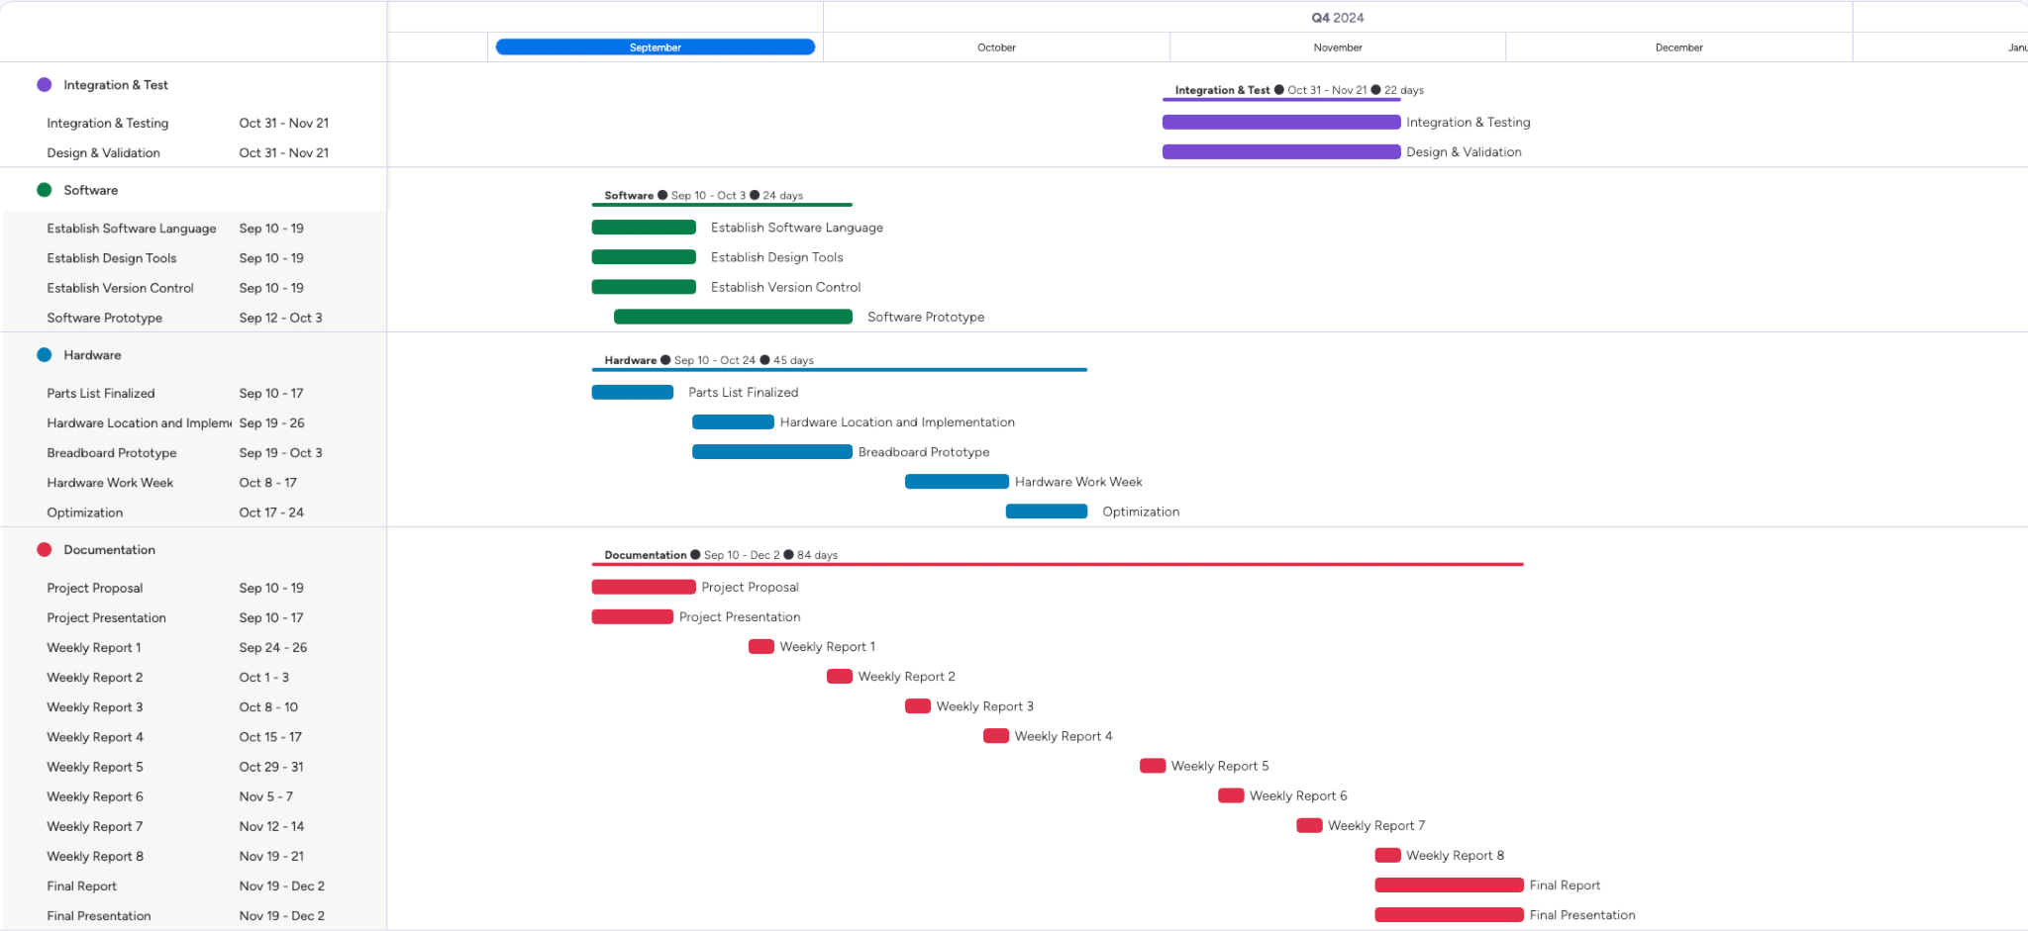

Figure 5: Gantt chart for the project schedule. This schedule is divided into four categories, documentation tasks, hardware tasks, software tasks, and integration & testing tasks. The chart displays the timeline of each task as well as the expected date of completion.

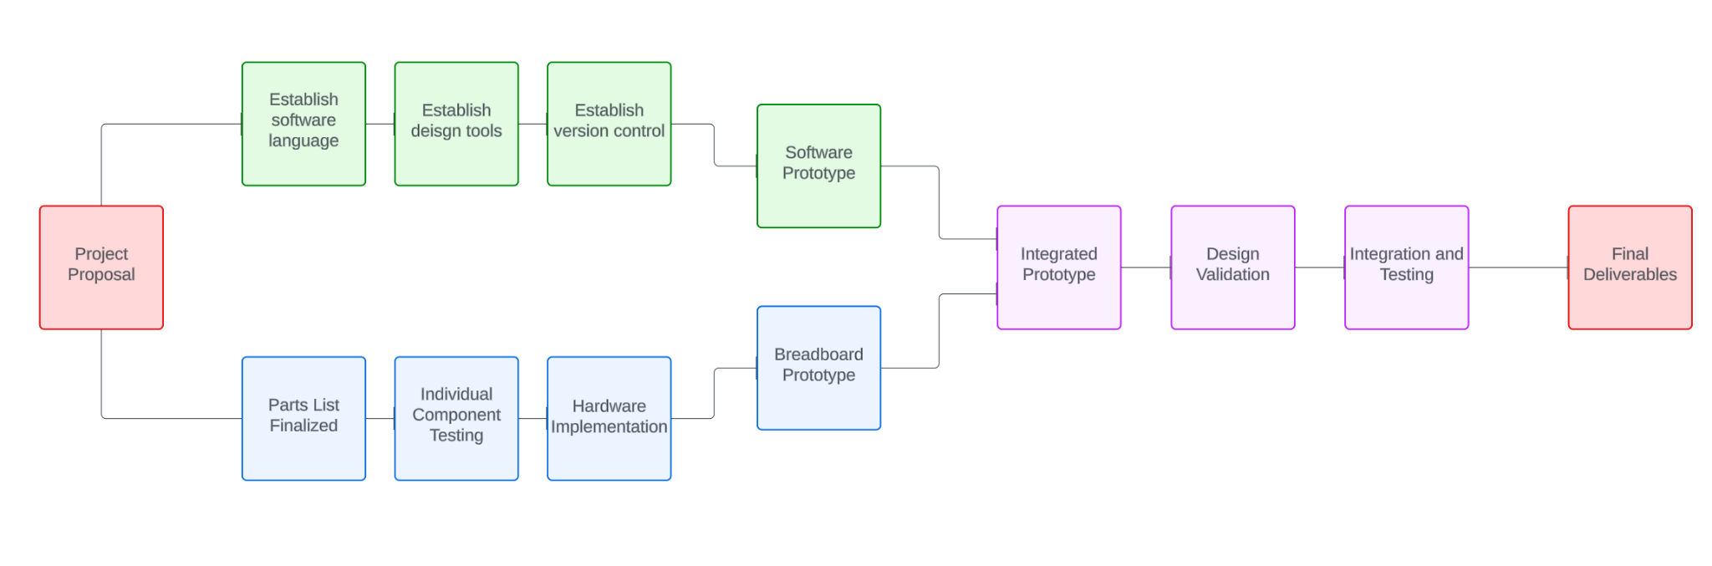

Figure 6: Pert chart for the project schedule. This schedule begins with our initial project proposal to stakeholders, then splits off into two development phases. The hardware development phase is in the blue blocks. The software development phase is in the green blocks. The integration & test phase as well as design validation phase is in purple. The schedule ends with final deliverables in red.

## Economic analysis

Although we have a $300 budget, we want to make something that is relatively inexpensive for volume production. Our product should be at a reasonable price so that consumers can afford the product. For volume production, certain materials would be manufactured at a cheap rate compared to consumer bought materials, which would bring down the cost of production and bring down the cost of the product. Even with this in mind, we have to realize that our design uses sensors that are relatively expensive, which makes sense for what they can do. So even if we can bring down the costs as much as possible, a real volume production cost would be around $100 per cane.

The system parts we are using are available through multiple vendors because they are commonly used materials that anyone can easily purchase. For our prototype, we will be primarily using Amazon to source our materials, as well as reuse materials from past projects. However, if we were doing volume production, we would definitely find a different vendor that would give us materials at cheaper costs. The goal of our project is to avoid maintenance and support for our product. That is because we aim to create something that is reliable whenever it is used, which is extremely important for what our product is made to be used for. If there are inaccuracies in our product, that would cause a mistrust to be built between the product and the user, which would defeat the purpose of this advanced walking stick. However, the only possible maintenance our product would have is a calibration system to make sure objects are being recognized and a vibration feedback is actually being felt.

Tolerance is important in a product like ours where every second counts. Due to the nature of our system needing to have very little to no delays, if any value is off and it causes the system to have a huge delay, that could result in the death of a real person in the worst case scenario. It is important to have a range of tolerance so our system does not break down and become completely useless. We want to aim for 95% production yield, making sure every single product is working under the worst possible conditions before it is actually sold. As our cane does not use radio signals, this would comply with the FCC regulations. We would also need to make sure the vibrations do not cause any sort of electromagnetic interference. Besides that, we need to make sure our cane meets the consumer safety standards because it can be marketed globally.

## Societal, safety and environmental analysis (1/2 page; 2 points)

Our project will bring down the learning curve of using a blind walking stick due to the electronics used to support the user in different ways. The purpose of the sensors on the walking stick will be to detect anything in front of the stick, before the stick hits anything. This information will then be sent to the vibrating handle to let the user know this information. This quality of life feature gives the user more time to prepare for whatever action they decide to take. This is not to take away from the original purpose of a walking stick, which is to poke at things to decide what it is; it can still do that. The detrimental effects of our project will be a slightly heavier stick, which we are trying to alleviate, as well as the loss of privacy due to data collection for the purpose of improving the quality of our project.

On the hardware side, we have to be wary when connecting our electronics together as well as using them while on. When soldering wires together, we must make sure not to touch the hot metal tip in order to avoid burns. A safety precaution we can take is to wear gloves so that even if we touch the tip for a second, our skin will not get burned as easily. We also need to make sure everything is connected properly so that we do not accidentally short circuit something. To avoid short circuiting and make sure our electronics work properly, we can use a breadboard to make connections and test electronics, and double check our wires before soldering.

The environmental impacts of our project will be due to the materials used because this project is only used for helping blind people with navigation. We plan to use recyclable and reusable materials to build the project, such as aluminum metal. Not only is it recyclable, it is a light metal which reduces the weight of our project, making it more comfortable to use. We also plan to reuse materials from past projects for our own so that we do not introduce more waste into the environment.

## Itemized budget

| Part Type | Amount of Units | Vendor | Cost | Total Cost |
| --- | --- | --- | --- | --- |
| Walking Stick | 1 | Amazon | $17.99 | $17.99 |
| Power Button | 1 | Amazon | $9.99 | $9.99 |
| Vibrating Motor | 2 | Amazon | $7.59 | $7.59 |
| RPLiDAR | 1 | Amazon | $99.00 | $99.00 |
| Depth Camera | 1 | Owned | - | - |
| Lithium Ion Battery | 2 | Amazon | $12.99 | $12.99 |
| Supulse Battery Charger | 1 | Amazon | $12.99 | $12.99 |
| 3D Printing Service | - | FEDC | $1/hr + weight | $60 max |
| Soldering Kit | 1 | Amazon | $9.98 | $9.98 |
| Screws & Bolts | 1 | Amazon | $14.85 | $14.85 |
| Screwdriver Set | 1 | Walmart | $8.48 | $8.48 |
| Breadboard | 2 | Owned | - | - |
| Wire Spool | 1 | Amazon | $24.59 | $24.59 |
| Raspberry Pi Pico 2 | 2 | Amazon | $12.50 | $12.50 |
| TOTAL | $230.86 | | | |

# References

* [1] World Health Organization, Aug. 10 2023, “Blindness and Visual Impairment”, World Health Organization,[Online],Available: https://www.who.int/news-room/fact-sheets/detail/blindness-and-visual-impairment
* [2] Snowflake_tvi, "Lazarillo: A Free Accessible GPS App for the Blind and Visually Impaired," Perkins School for the Blind, Sep. 19, 2024. [Online]. Available: https://www.perkins.org/resource/lazarillo-free-accessible-gps-app-blind-and-visually-impaired/ (accessed Sep. 19, 2024).
* [3] MathWorks, "SLAM (Simultaneous Localization and Mapping)," MathWorks, Sep. 19, 2024. [Online]. Available: https://www.mathworks.com/discovery/slam.html (accessed Sep. 19, 2024).
* [4] I. Papagianopoulos, G. De Mey, A. Kos, B. Wiecek, and V. Chatziathasiou, "Obstacle Detection in Infrared Navigation for Blind People and Mobile Robots," Sensors, vol. 23, no. 16, p. 7198, Aug. 2023, doi: 10.3390/s23167198.
* [5] feelSpace GmbH, "feelSpace naviGürtel," feelSpace, Sep. 19, 2024. [Online]. Available: https://feelspace.de/en/ (accessed Sep. 19, 2024).
* [6] WeWalk, "WeWalk - Brand New Smart Cane 2," WeWalk, Sep. 19, 2024. [Online]. Available: https://wewalk.io/en/ (accessed Sep. 19, 2024).
* [7] Security Robotics, "SPOT – the allrounder," Security Robotics, Sep. 19, 2024. [Online]. Available: https://security-robotics.de/en/allrounder-spot (accessed Sep. 19, 2024).

# Appendices

## Product datasheets

Depth Camera Datasheet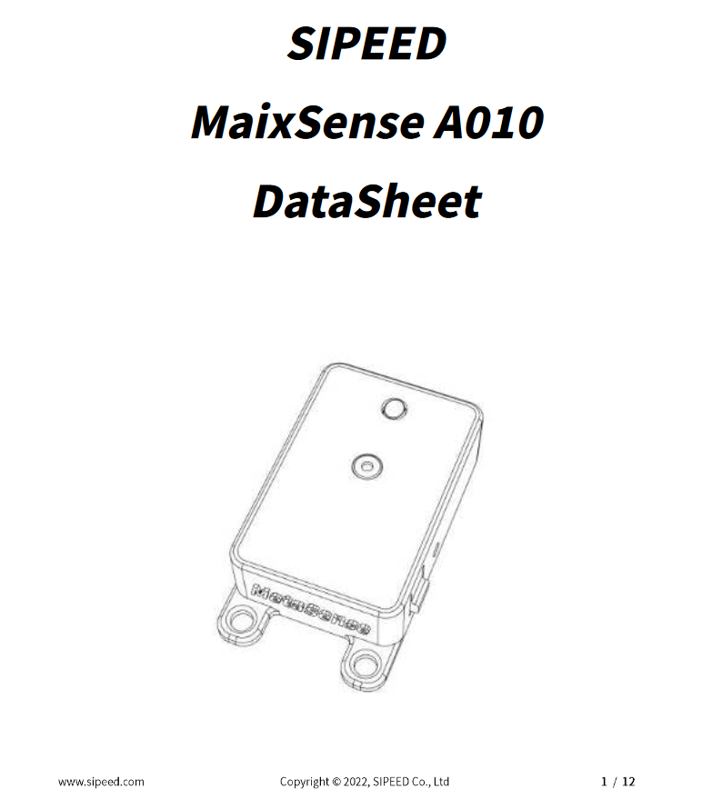

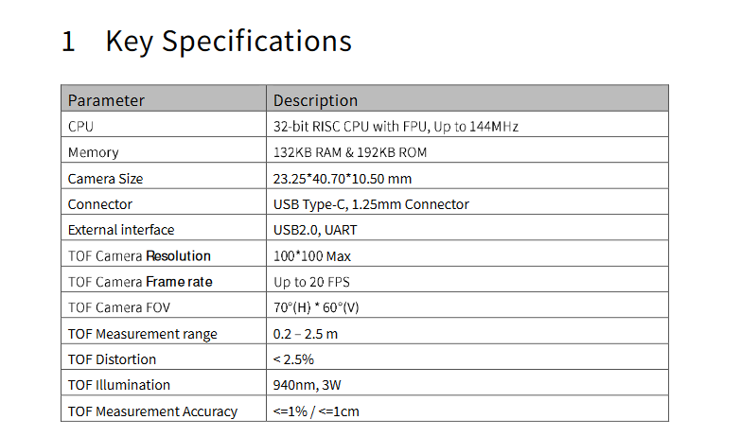

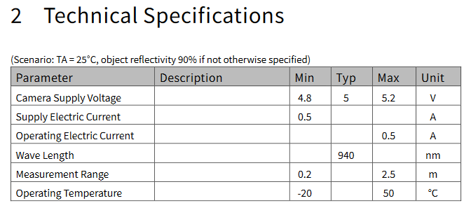

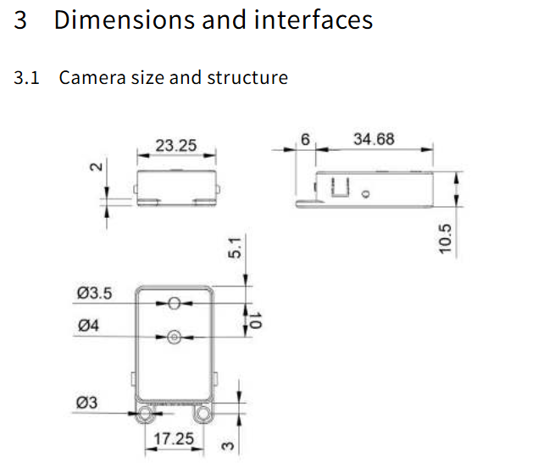

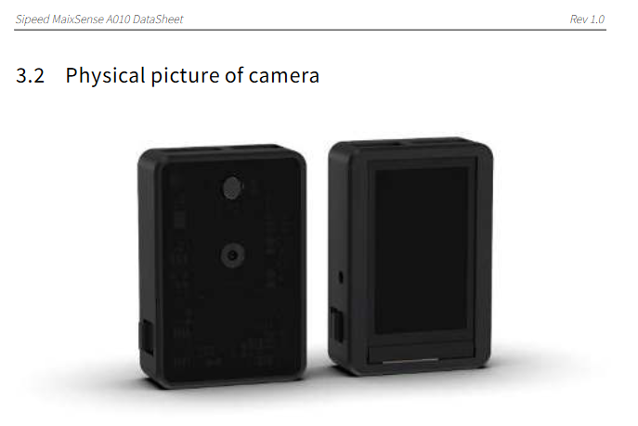

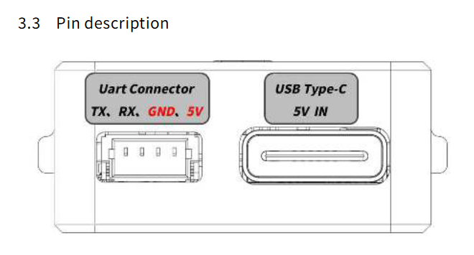

LiDAR Data Sheet

LiDAR Datasheet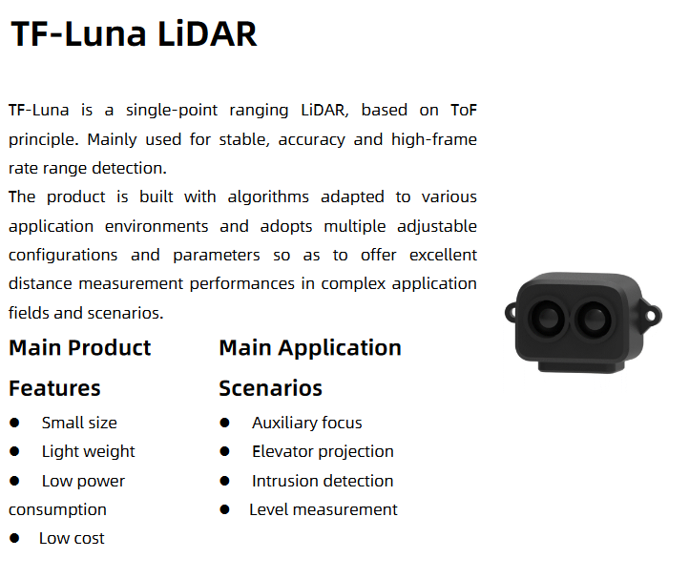

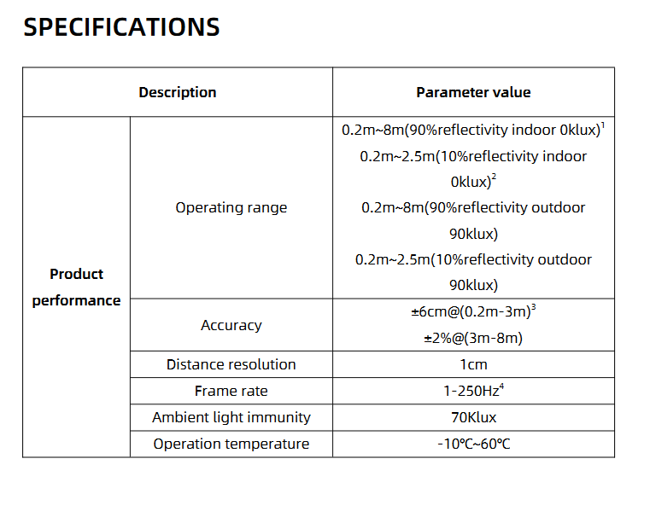

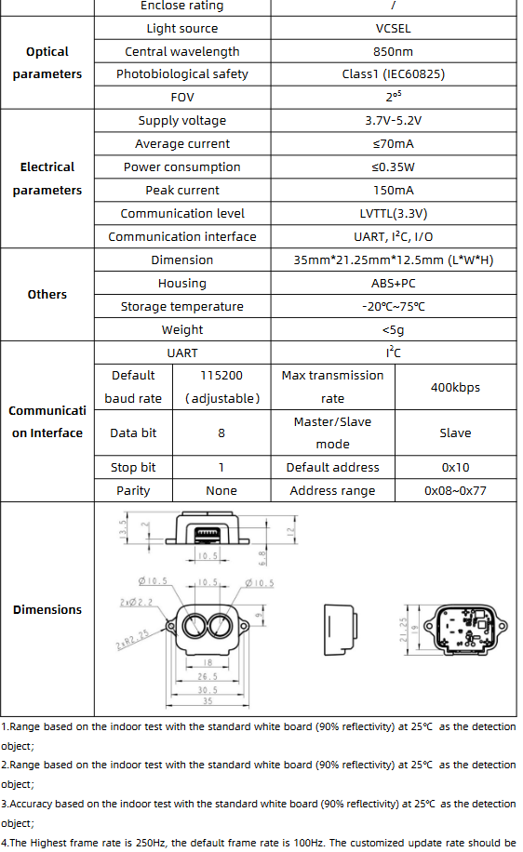

Microcontroller Data Sheet

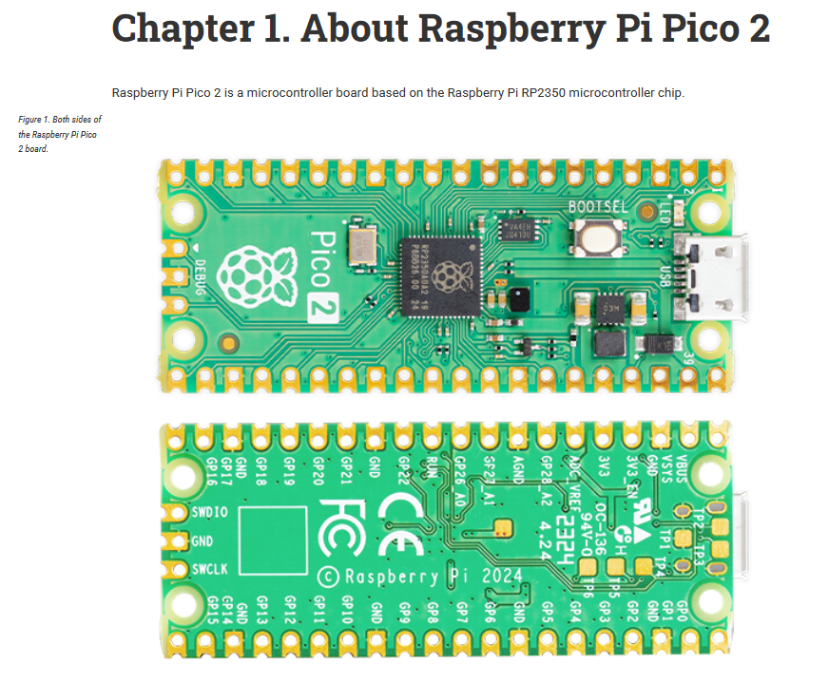

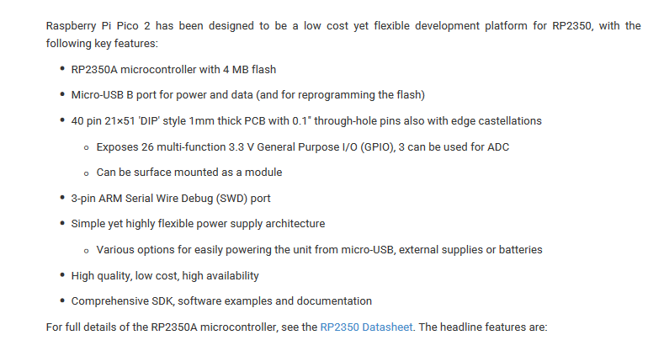

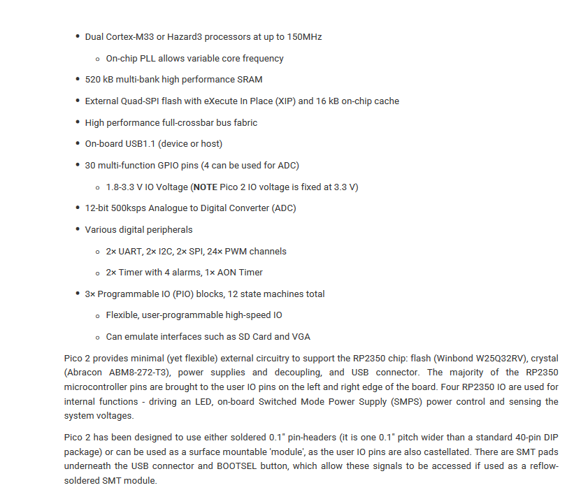

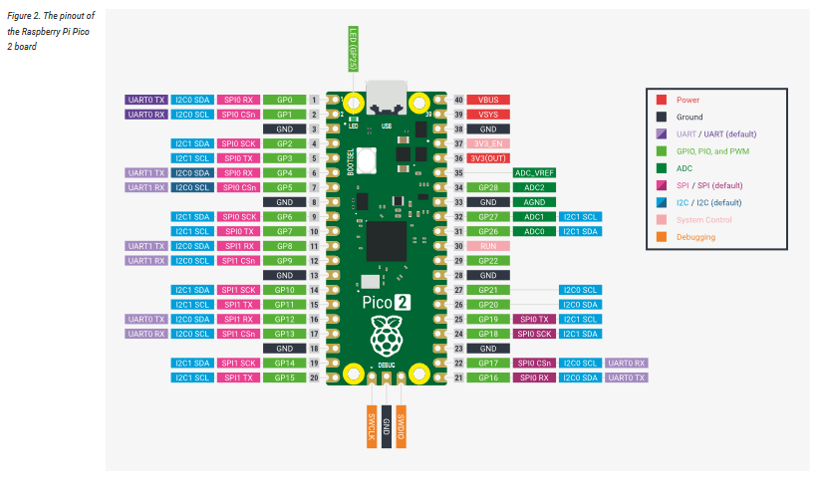

## Bios and CVs

Team Member: Diana Canchola





Team Member: Alyan Tharani

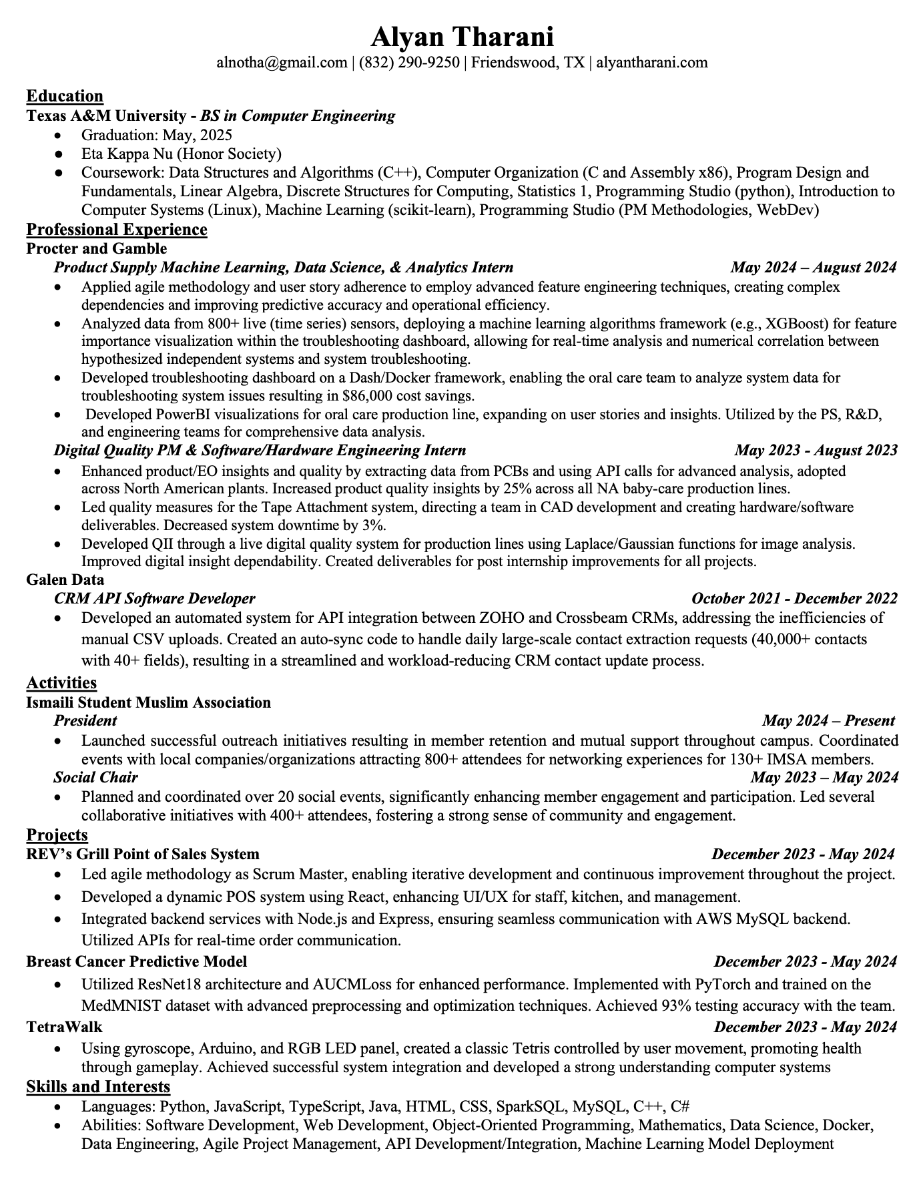

Team Member: Jack Couture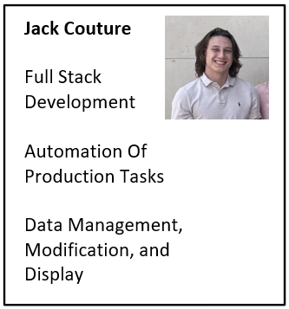

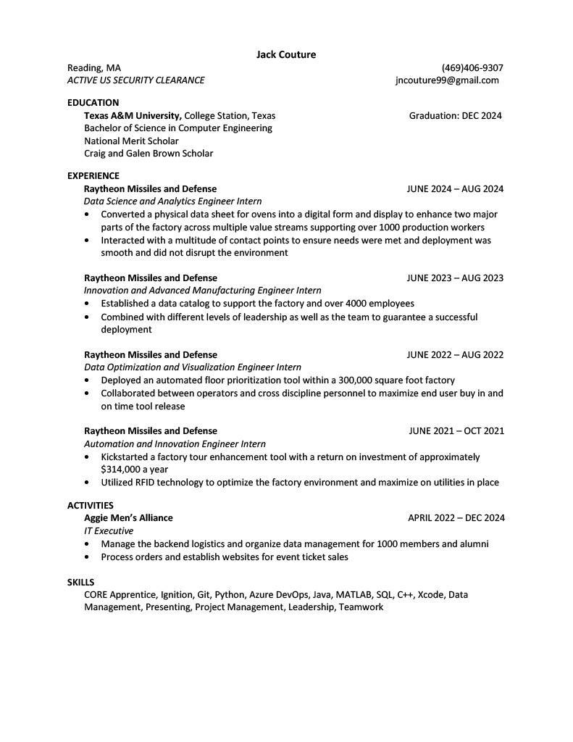

Team Member: Noah Kilpatrick

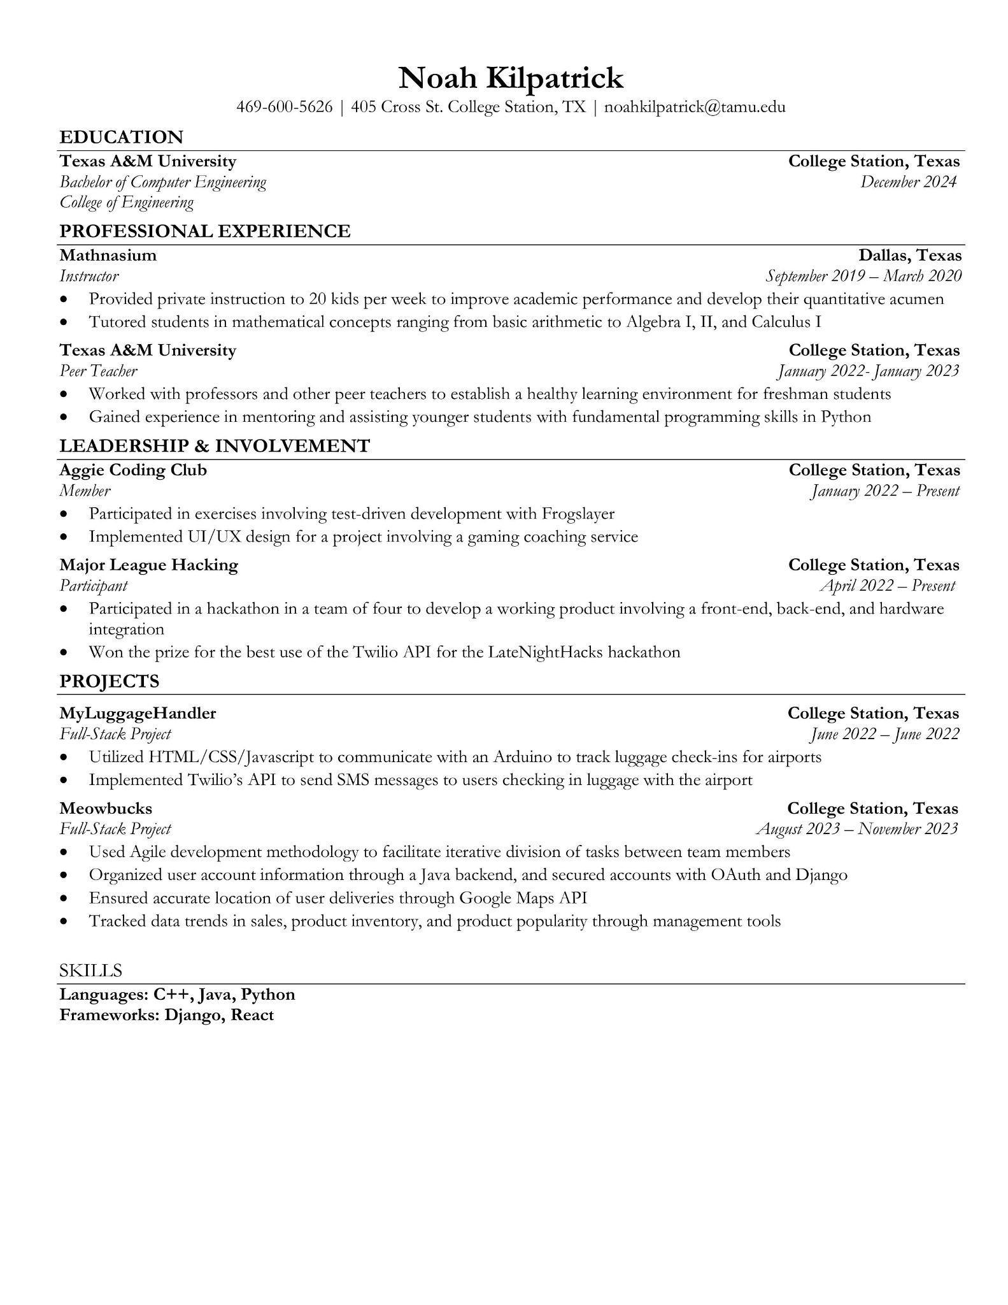

Team Member: Jack Letsinger

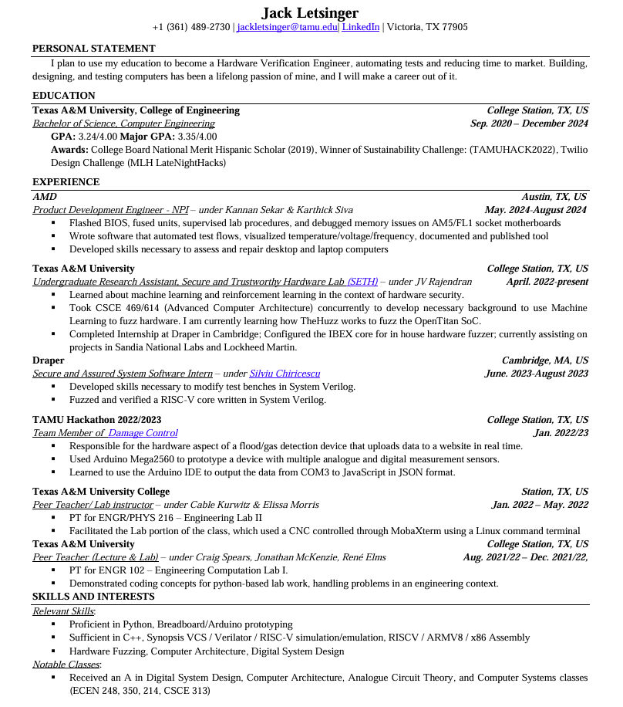

Team Member: Ryan Wu